## Abbreviation：

RC: RNN + CNN1D

CP: CNN1D + parallel structure

CR: CNN1D + residual block

X: XGBoost

S: SVM

A: ANN

S: Shuffle

N: No shuffle

Tr: Training set

V: Validation set

T: Test set

Files[5]: G07_Freezing_Trial1_trial_1_emg.csv

Files[6]: G08_FoG_1_trial_1_emg.csv

Files[7]: G08_FoG_2_trial_1_emg.csv

Files[30]: G09_Walking_trial_2_emg.csv

Files[31]: G09_Walking_trial_4_emg.csv

Files[32]: G09_Walking_trial_6_emg.csv

Files[33]: G11_Walking_trial_2_emg.csv

Files[34]: G11_Walking_trial_4_emg.csv

Files[35]: P231_M050_A_Walking_trial_2_emg.csv

e.g.

RC_S_TR: Training set of RNN + CNN1D model with shuffle

multi_5: multiclassification(1:2:6) drop files[5,30,31,32,33,34,35] out.

binary_6: binary classification(0:others) drop files[6,30,31,32,33,34,35] out.

2-6_7: binary classification(2:6) drop files[7,30,31,32,33,34,35] out.

## Data

All data with same label1 and label2 will be used and detrended with lambda 50, low pass filtered with 300HZ.

Window size: 1024

Step size: 512

Files[5,6,7] have data with label 0,1,2.6. They will be leave out respectively for test in three trials.

Files[30,31,32,33,34,35] only have data with label 0. They will be leave out for test in all three trials.

Only 4 files contain data with label 6 and one of them have only 4 instances. Only 5 files contain data with label 1 and one of them have only 4 instances.

|  |  |  |  |  |
| --- | --- | --- | --- | --- |
| File | Class 0 | Class 1 | Class 2 | Class 6 |
| G07_Freezing_Trial1_trial_1_emg.csv | 45 | 13 | 9 | 94 |
| G08_FoG_1_trial_1_emg.csv | 60 | 52 | 57 | 92 |
| G08_FoG_2_trial_1_emg.csv | 10 | 126 | 85 | 108 |
| P551_M050_2_A_FoG_trial_1_emg.csv | 5 | 0 | 13 | 4 |
| P551_M050_2_B_FoG_trial_1_emg.csv | 16 | 13 | 65 | 0 |
| P812_M050_2_B_FoG_trial_1_emg.csv | 20 | 1 | 47 | 0 |
| G09_Walking_trial_2_emg.csv | 48 | 0 | 0 | 0 |
| G09_Walking_trial_4_emg.csv | 33 | 0 | 0 | 0 |
| G09_Walking_trial_6_emg.csv | 40 | 0 | 0 | 0 |
| G11_Walking_trial_2_emg.csv | 56 | 0 | 0 | 0 |
| G11_Walking_trial_4_emg.csv | 39 | 0 | 0 | 0 |
| P231_M050_A_Walking_trial_2_emg.csv | 50 | 0 | 0 | 0 |

Because the data of some class only exist in several files, it’s hard to do leave one patient out test. This time I tried to leave the data of some files out for test, then shuffle or not shuffle and split the rest data for training and validation.

I tested on 6 models, all performance good in binary classification. Some models performance also good in classification with class 2 and class 6, besides leave Files[5] out. And none of them can classify class 1 well.

I think the reasons maybe:

* Class 1 is too close to the other classes and unclassifiable
* 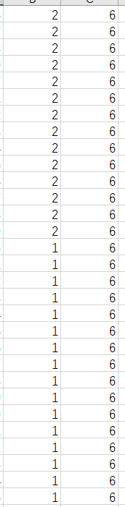The labels are wrongly labeled, because in some segments of some trials, labelers have completely different judgment like this:
* The quality of the signal is not good. Because some papers recommend, that frequency range of sEMG signals is 5-500Hz. But in some trials some channels’ signal are starkly influenced by low frequency noise.

